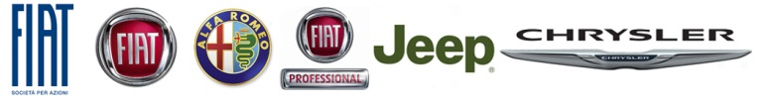

Clareview Car Sales Joins
FIAT Group Automobiles Ireland Dealer Network

Highlights:
- Clareview Car Sales & Rentals joins FGAI Dealer Network
- New appointment to represent all five FIAT Group brands in the Mid-West region
- Expansive, easily-accessed site ideal for stocking and displaying five different brands
- Clareview boasts state-of-the-art service centre with plans to revamp sales premises

Press Release:
Clareview Car Sales & Rentals is the latest dealership to join the fast-growing FIAT Group Automobiles Ireland network. The Limerick-based dealership is set to represent all five of the Group’s brands – FIAT, Alfa Romeo, FIAT Professional, Jeep and Chrysler – in the Mid-West under the stewardship of Dealer Principal Neil O’ Sullivan and Chairman John Leahy.

Facilitating all five brands will not be an issue thanks to Clareview’s expansive two-acre Ennis Road site, which also has a state-of-the-art six-bay service and aftersales centre. Clareview also has plans to revamp its sales facilities by the end of 2014 but in the interim is focussed on building awareness the Fiat Group range in the region and engaging with its existing clients and customers.

Clareview has been in business for nearly three decades and brings with it the experience, dedication and determination needed to compete in today’s challenging market. Ideally located on Limerick’s N18 (Ennis Road), just minutes from the new Shannon Tunnel, Clareview is not only highly visible to passing retail, commuting and event traffic, it also has the potential to attract and serve a huge number of customers in the greater Mid-West region.

Adrian C. Walsh, Managing Director of FIAT Group Automobiles Ireland, said of the new appointment: “We’re delighted to welcome Clareview Car Sales & Rentals to the FIAT Group family and we’re particularly excited to have all five of our brands represented so enthusiastically in the region by such a long-established and highly-regarded dealership.”

- Ends –

Photo Captions:
120118_F_Clarview_03.jpg – Clareview Dealer Principal Neil O’ Sullivan (L) and Chairman John Leahy (R)
120118_F_Clarview_04.jpg – (L-R) Chairman John Leahy; Dealer Principal Neil O’ Sullivan and FGAI Brand Development Manager Brian Higgins
120118_F_Clarview_05.jpg – (L-R) Clareview Chairman John Leahy; Dealer Principal Neil O’ Sullivan; Car Rental Manager Colman Fox; FGAI Brand Development Manager Brian Higgins; Sales Executive Dave Barry and Marketing Manager Maeve Newman.

